**PYTHON INSTALLATION GUIDE**

STEP 01: Download the following resources from these websites:

<https://sourceforge.net/projects/omniorb/files/omniORBpy/omniORBpy-4.2.2/>

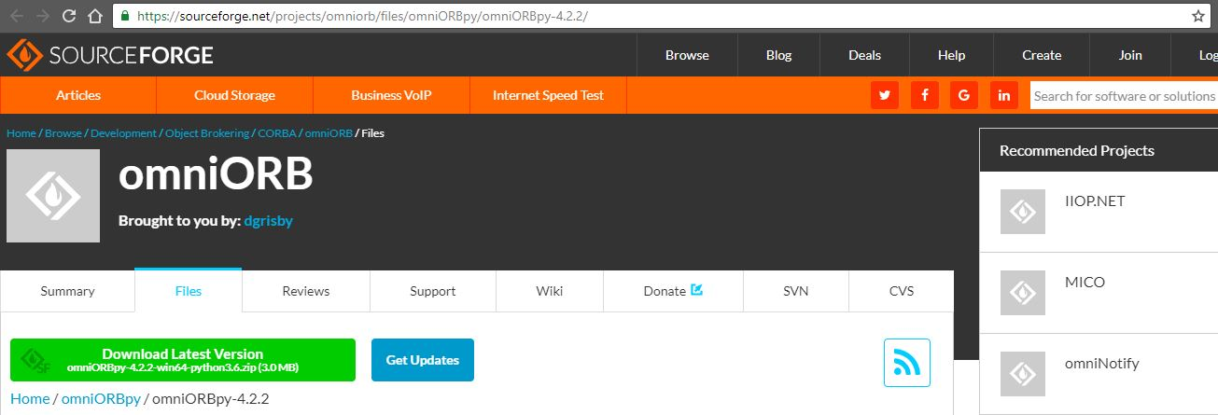

<https://www.python.org/downloads/>

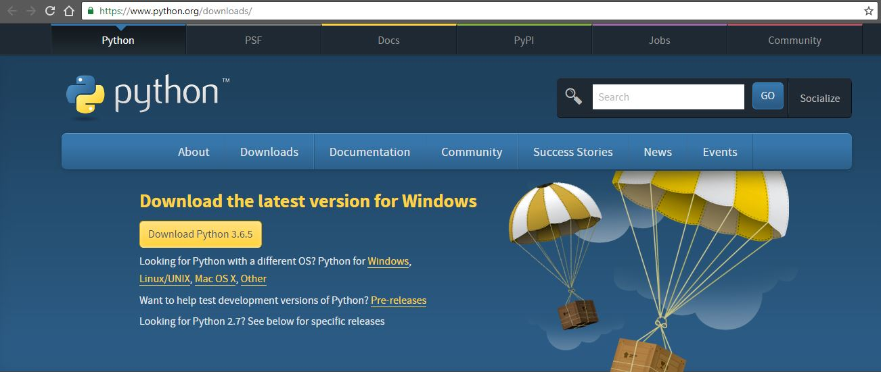

STEP 02: Double-click the “python-3.6.5” installer. Click “Install Now”.

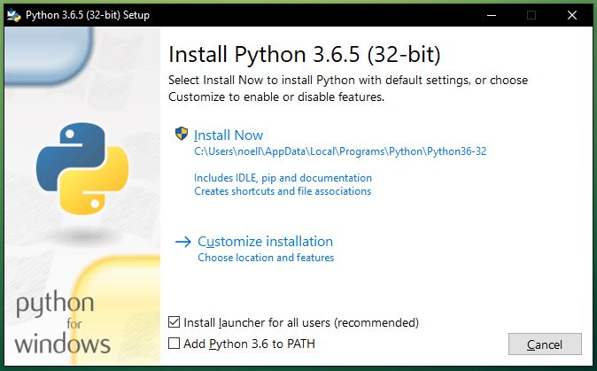

STEP 03: Wait for the installation process to finish.

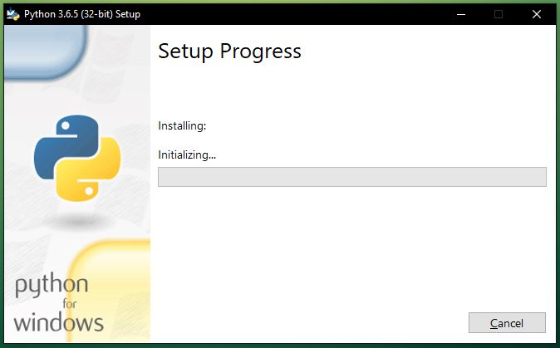

STEP 04: Click the “Disable path length limit”, then click Close.

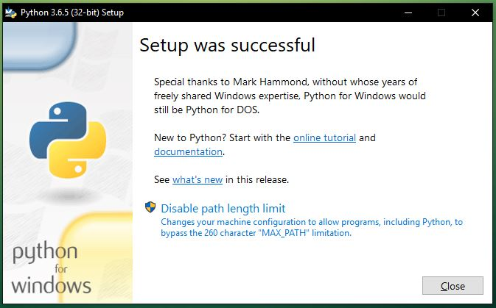

STEP 05: In setting up the System Environment, go to Control Panel. Click “System”.

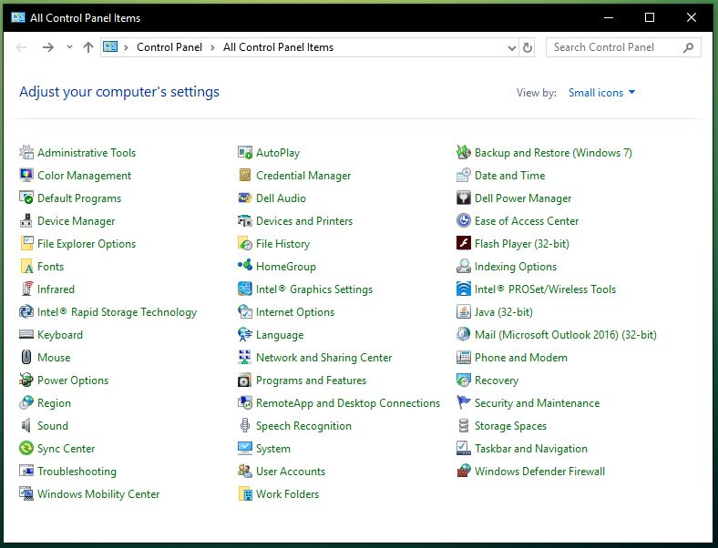

STEP 06: Click “Advance system settings”.

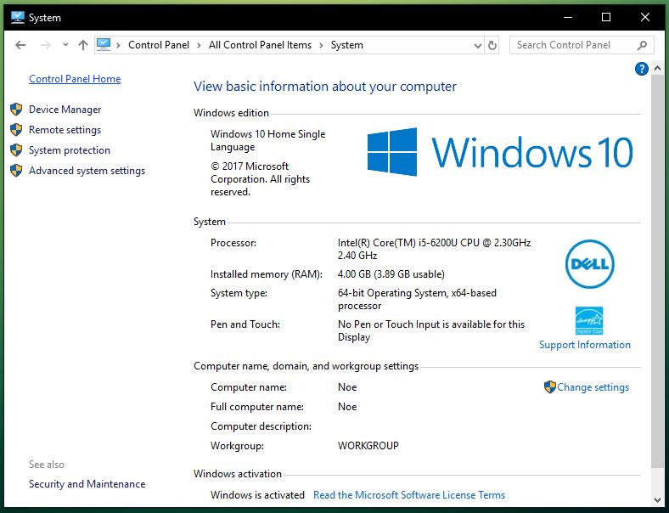

STEP 07: Under System Properties>Advanced tab, click “Environment Variable…”

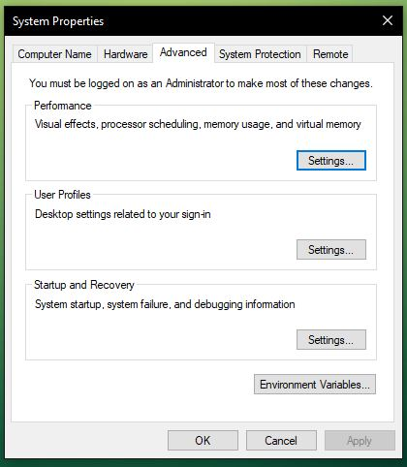

STEP 08: Under the “User variables”, select “Path”, then click “Edit…”.

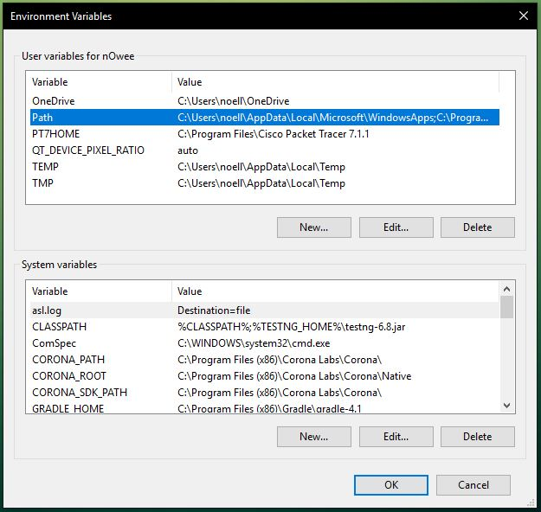

STEP 09: Click “Browse…”.

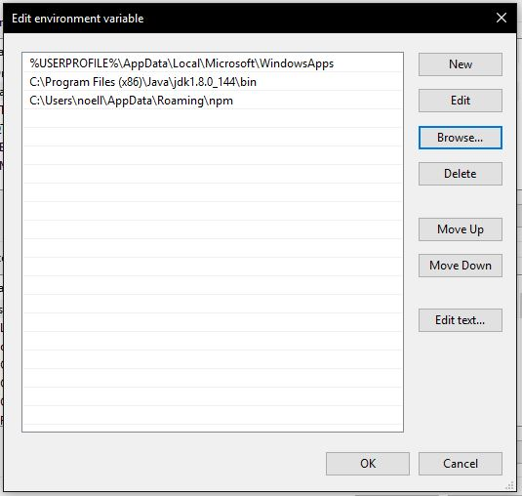

STEP 10: Locate “...\omniORBpy-4.2.2\bin\x86_win32” and click OK.

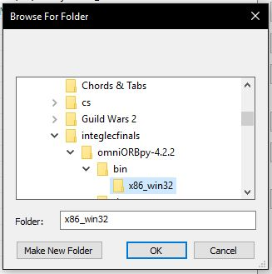

STEP 11: Click OK.

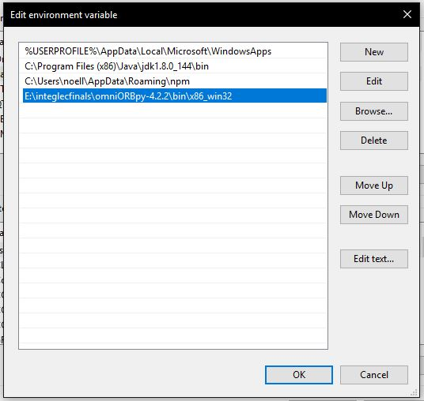

STEP 12: Under “System variables”, click “New…”.

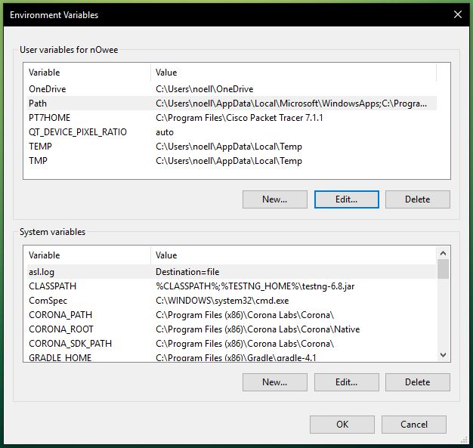

STEP 13: Provide a variable name (ex. PYHTON_PATH).

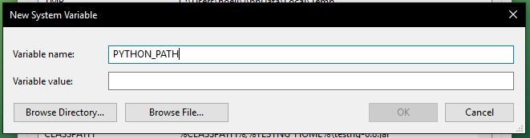

STEP 14: Under the “Variable value”, then click “Browse Directory…” and locate “...\omniORBpy-4.2.2\lib\python” and “...\omniORBpy-4.2.2\lib\x86_win32” folder (make sure to use a semicolon in between to add them both).

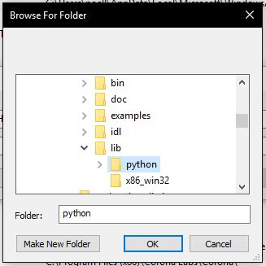

STEP 15: Click OK.

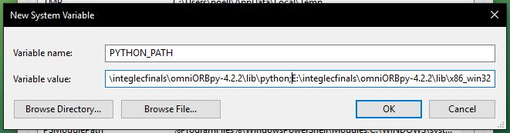

STEP 16: Click OK.

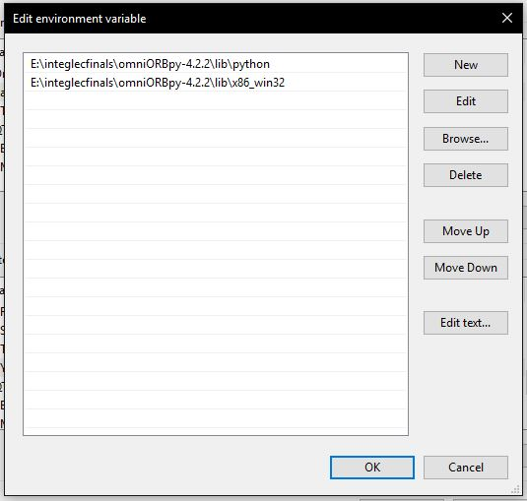

STEP 17: Click OK.

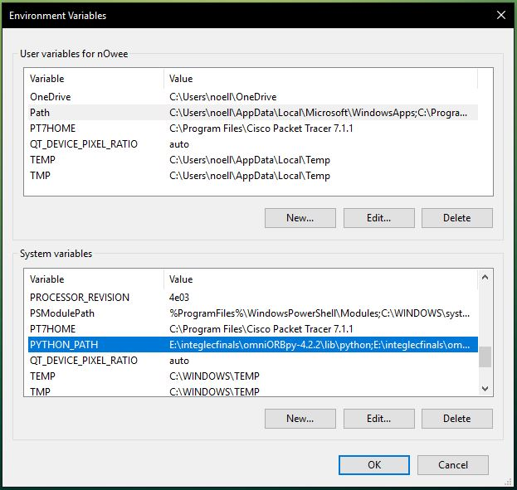

STEP 18: Click OK.

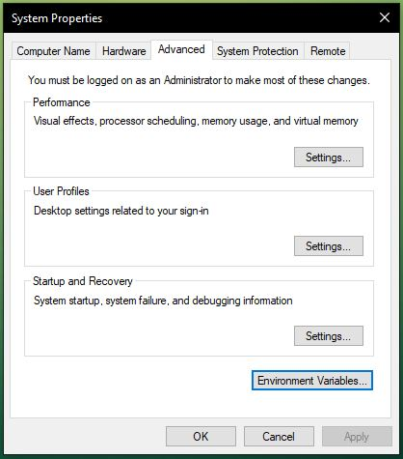

STEP 19: Restart the computer for the changes in the Environment Variables to take effect.

